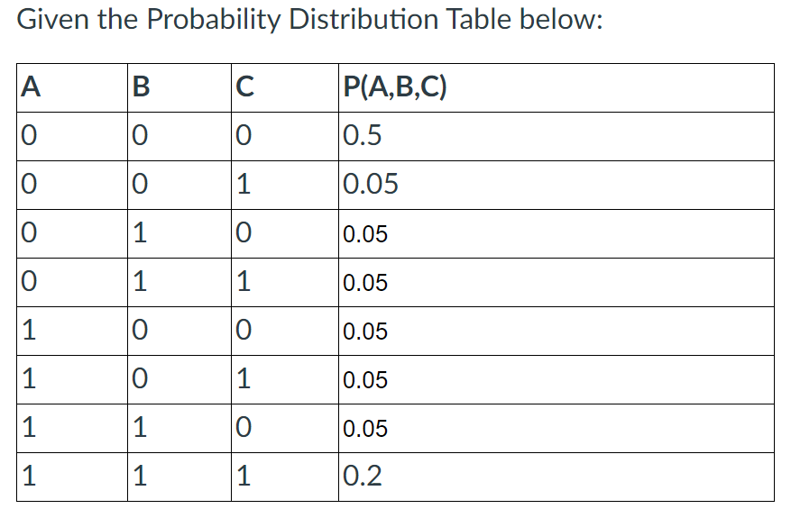

1. Calculate P(A=0) to two decimal places.
2. Calculate P(B=0|A=0) to two decimal places.
3. Calculate P(B=0|A=1) to two decimal places.
4. Calculate P(A=1,B=0|C=1) to two decimal points.
5. Calculate P(C=1|A=1,B=0) to two decimal points.

1) Between 0.64 and 0.66

2) Between 0.836 and 0.856

3) Between 0.276 and 0.296

4) Between 0.133 and 0.153

5) Between 0.49 and 0.51

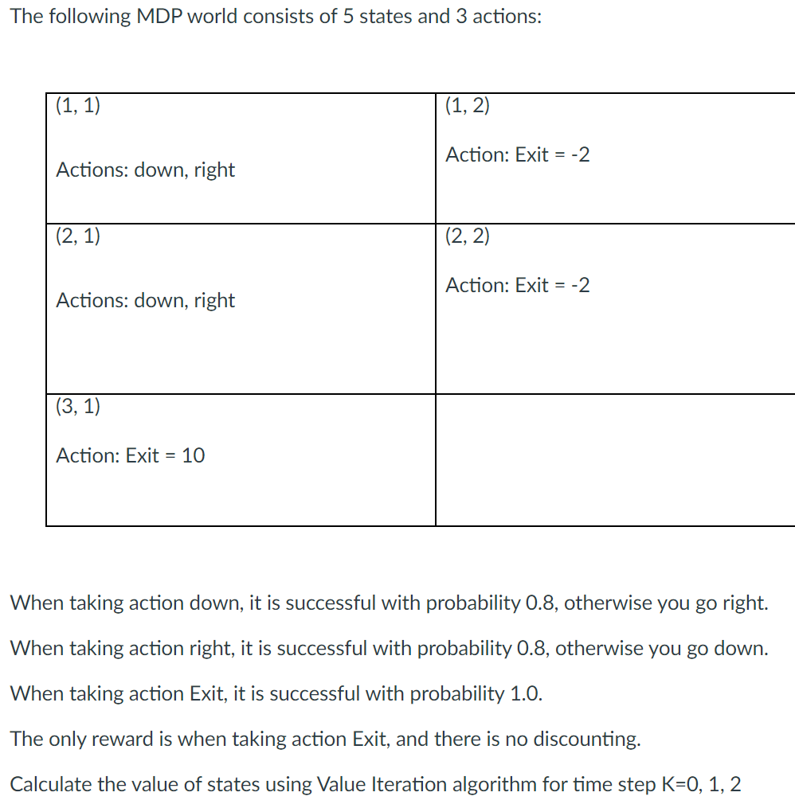

1. Provide the value for State (1,1) at time step 0:  V0(1,1) =
2. Provide the value for State (1,1) at time step 1:  V1(1,1) =
3. Provide the value for State (1,1) at time step 2:  V2(1,1) =
4. Provide the value for State (1,2) at time step 0:  V0(1,2) =
5. Provide the value for State (1,2) at time step 1:  V1(1,2) =

1=0, 2=0, 3= -0.4, 4=0, 5= -2

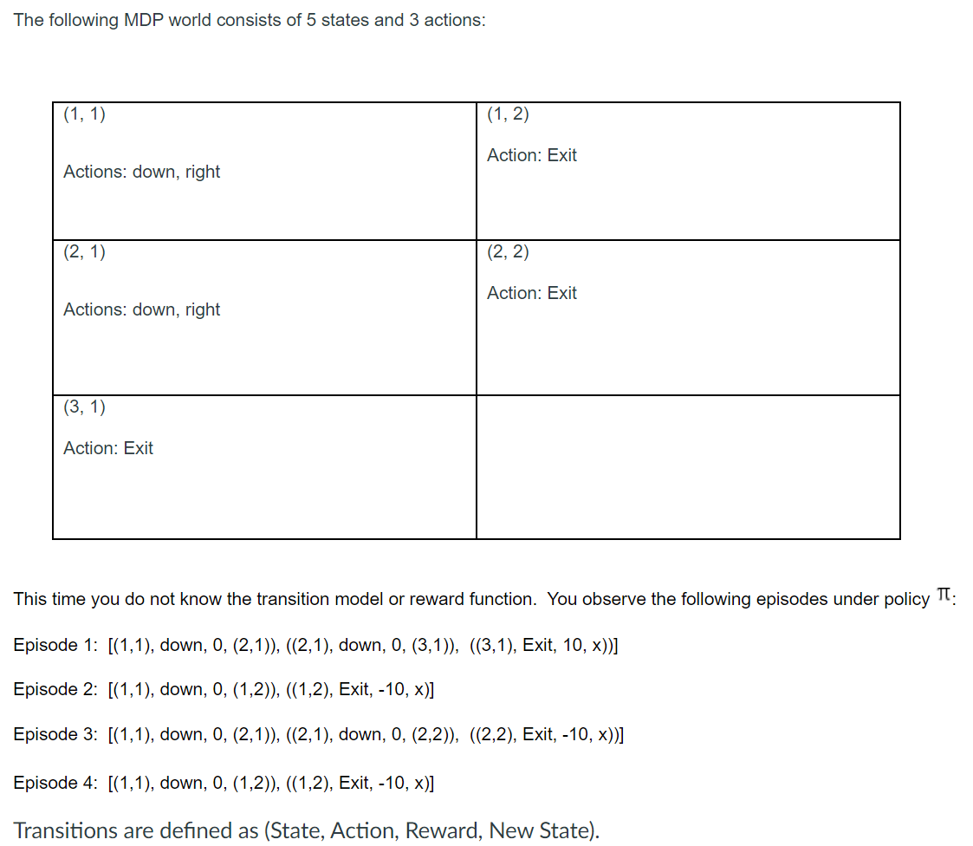

1. Using our model based learning approach, what is P( (1,2) | (1,1), Down)?
2. Using our model based learning approach, what is P( (2,1) | (1,1), Down)?

6=.5, 7=.5

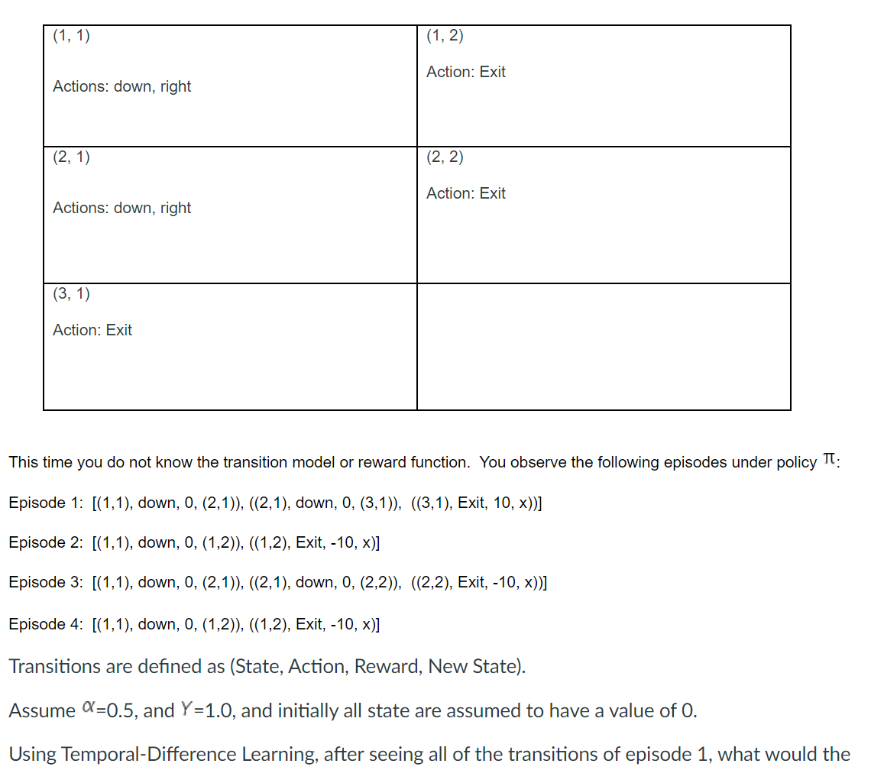

1. value estimate be for state (3,1).
2. the value estimate be for state (1,1).
3. the value estimate be for state (1,2).

8=5, 9= -2.5, 10= -7.5

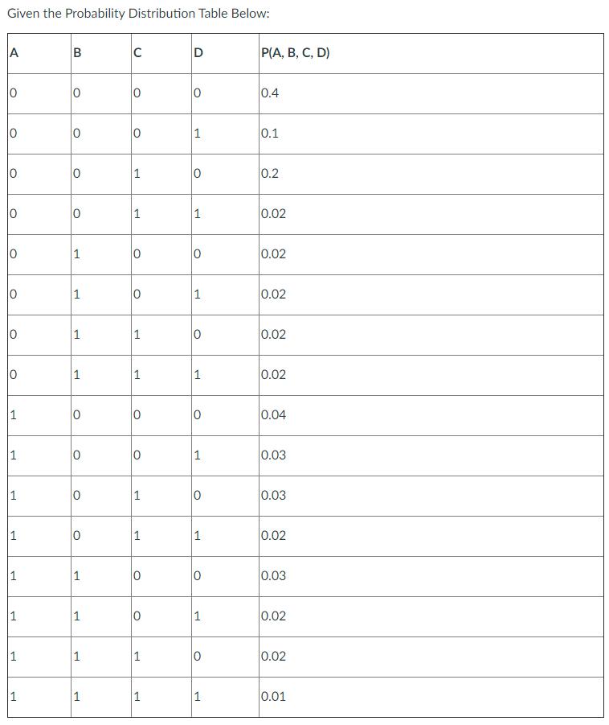

1. Calculate the P(D=0|A=1,B=0,C=1)
2. Calculate the P(D=1|A=1,B=0,C=1)

1= .6, 2=.4

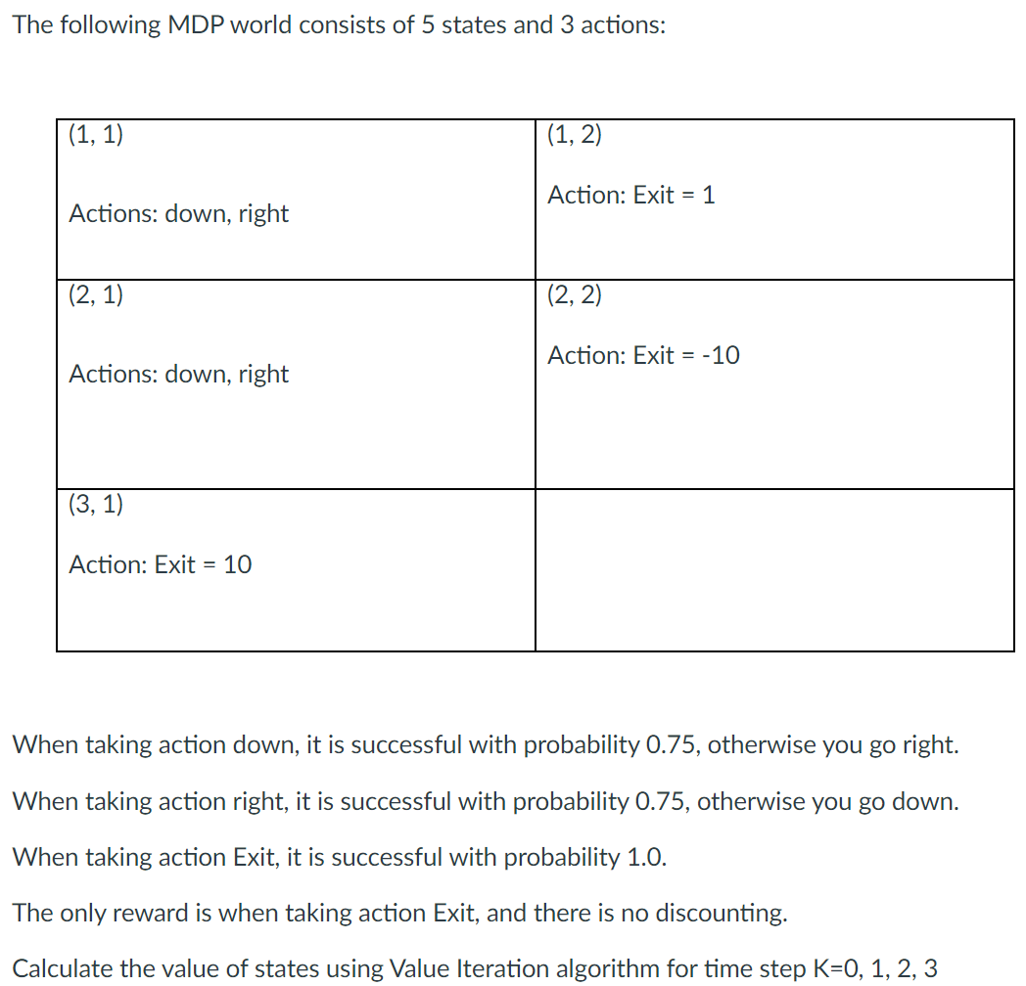

1. Provide the value for State (1,1) at time step 2:  V2(1,1) =
2. Provide the value for State (2,1) at time step 2:  V2(2,1) =
3. Provide the value for State (3,1) at time step 2: V2(3,1) =
4. Given the MDP as described in question 1, after two iterations of the Value Iteration algorithm, what action would the Policy Extraction Algorithm assign to state (1,1)?
5. Provide the value for State (1,1) at time step 3:  V3(1,1) =
6. Provide the value for State (2,1) at time step 3:  V3(2,1) =
7. Provide the value for State (3,1) at time step 3:  V3(3,1) =

1. Given the MDP as described in question 1, after three iterations of the Value Iteration algorithm, what action would the Policy Extraction Algorithm assign to state (1,1)?

3= 0.75, 4=5, 5=10, 6=Right,7= 4, 8=5, 9=10, 10=Down

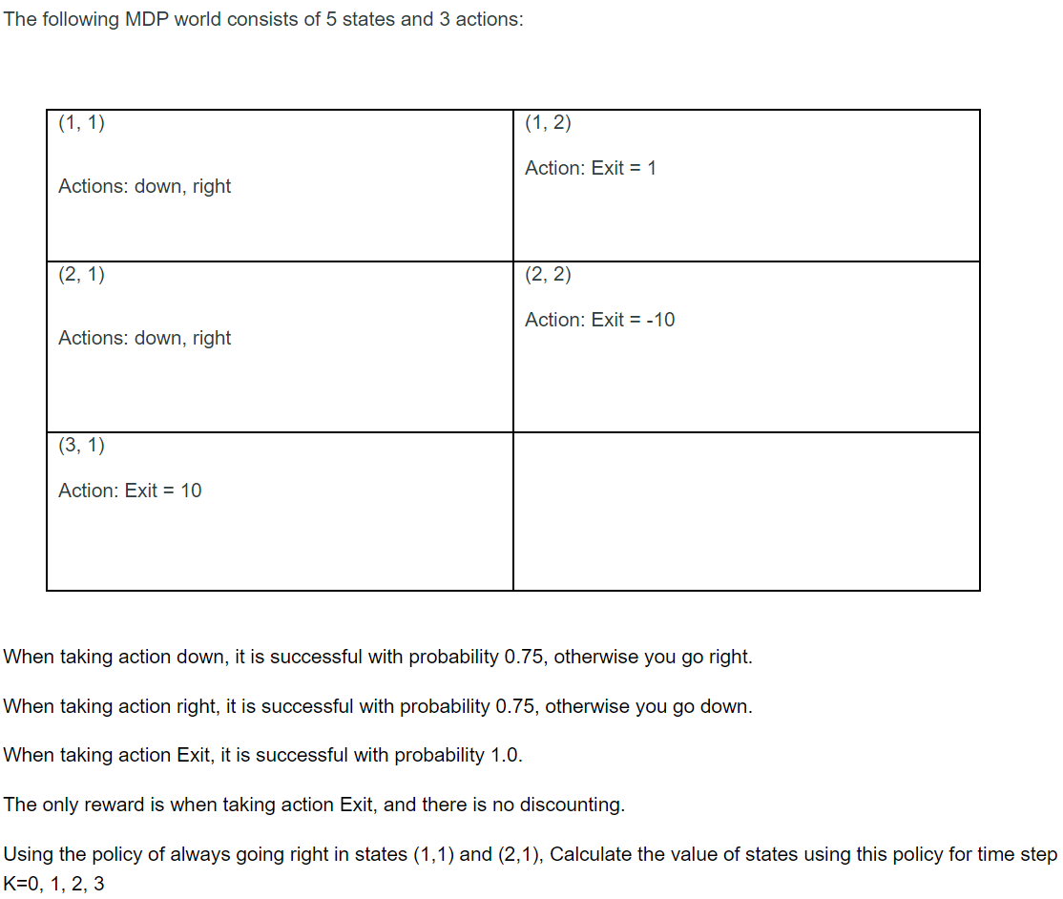

1. Provide the value for State (1,1) at time step 2:  V2(1,1) =
2. Provide the value for State (2,1) at time step 2:  V2(2,1) =
3. Provide the value for State (1,1) at time step 3:  V3(1,1) =
4. Provide the value for State (2,1) at time step 3:  V3(2,1) =

11= .75, 12= -5, 13= -.5, 14= -5,

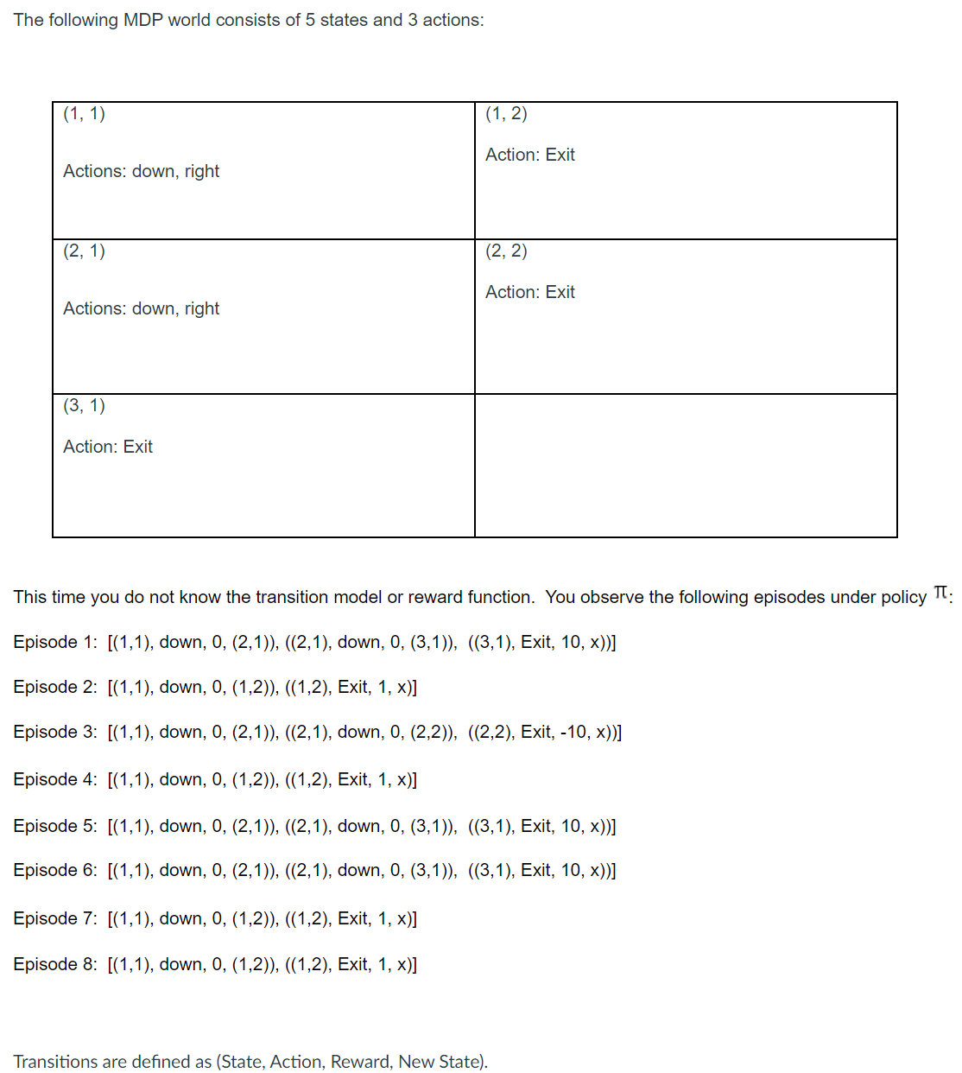

1. Using our model based learning approach, what is P( (1,2) | (1,1), down)?
2. Using our model based learning approach, what is P( (2,2) | (2,1), down)?

15= .5, 16= .25,

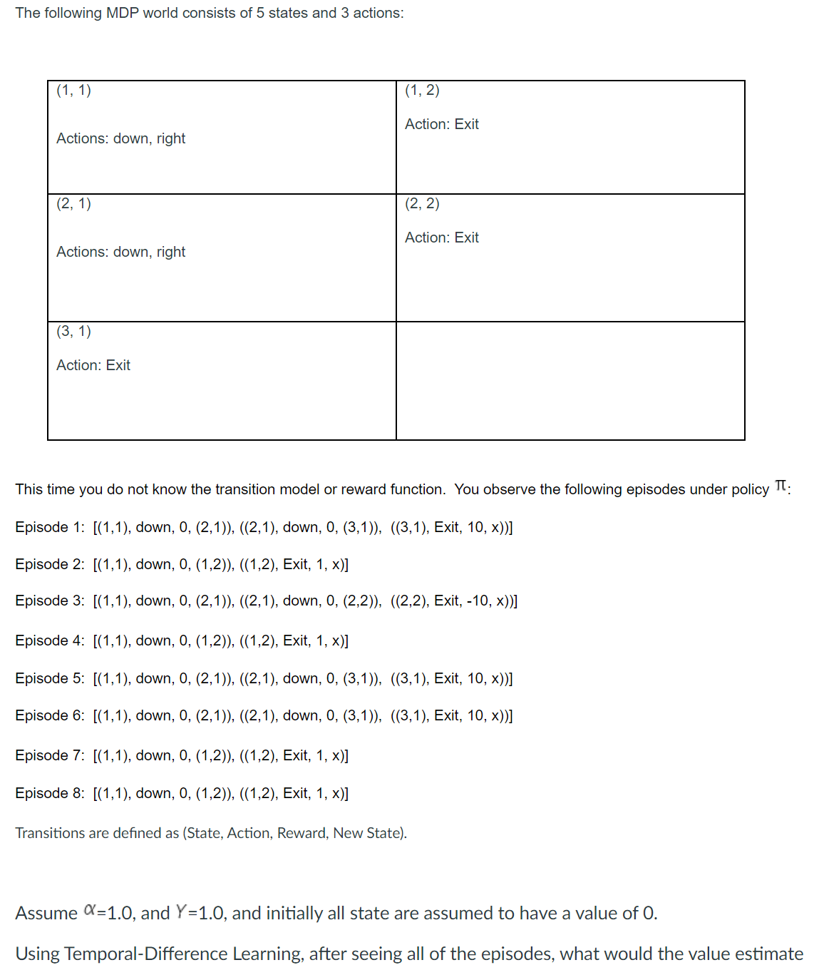

1. be for state (1,1).
2. be for state (2,1).

17= 1, 18= 10,

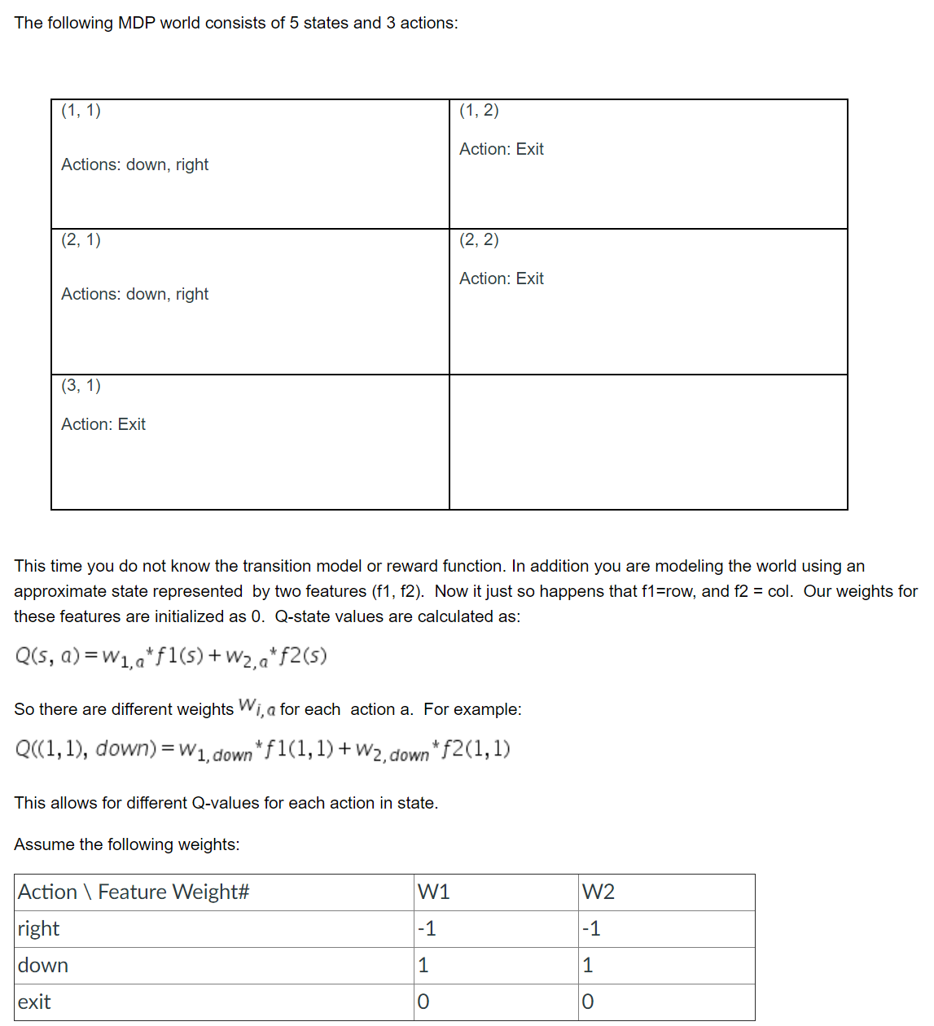

1. What is the approximate Q-value for q-state (1,1), right
2. What is the approximate Q-value for q-state: (1,1), down
3. What is the approximate Q-value for q-state: (1,1), exit
4. What action would policy extraction return for state (1,1)

19= -2, 20= 2, 21= 0, 22= Down

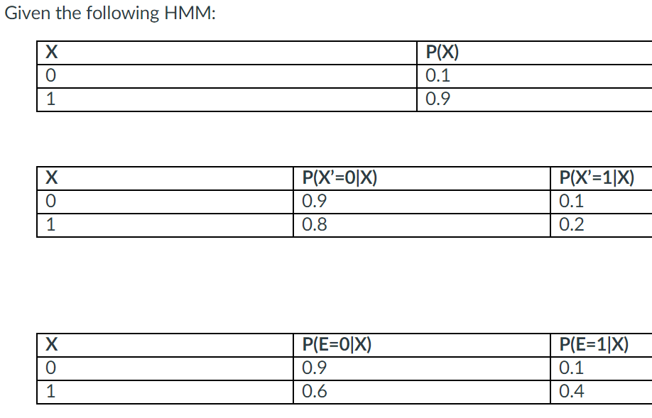

 If no sensor data was received, calculate the stationary distribution, and provide the value to two decimal places for

1. P(X∞=0):
2. P(X∞=1):

Calculate the following probability for time step 1 before seeing any evidence to 2 decimal places:

1. P(X1=0) =
2. P(X1=1) =

If our sensor detects E=1 at time step 1, calculate for time step 1 to three decimal places the probability that X1=0 :

1. P(X1=0) =

If our sensor detects E=1 at time step 1, calculate for time step 1 to three decimal places the probability that X1=1:

1. P(X1=1) =

1= .889, 2= .111, 3= .81, 4= .19, 5= .516, 6= .484

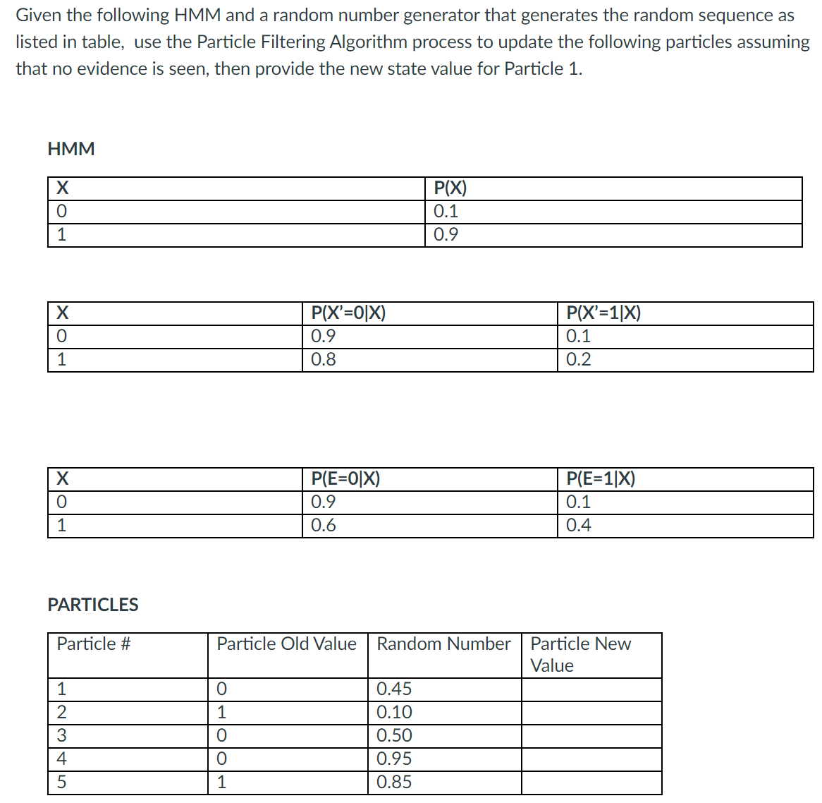

1. Provide the new state value for Particle 1:
2. Provide the new state value for Particle 5:
3. Provide the weight for the new particle 1 (2 decimal places):
4. Provide the weight for the new particle 5 (2 decimal places):

7= 0, 8= 1, 9= .10, 10= .40